
MODULE K31
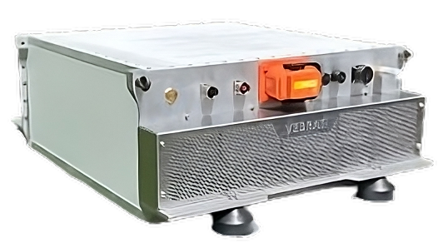



VEBRAT’s electric prime movers can be powered with batteries using the lithium iron phosphate technology (LiFePO4), the safest lithium technology, offering a superior price-quality ratio and exceptional levels of durability .

Security
LiFePO4 batteries do not ignite or explode in case of prolonged charging, overcharge, impact or perforation.


Light weight
LiFePO4 batteries weight almost two times less than lead batteries.

High durability
LiFePO4 batteries support more than 4 000 charge-and-discharge cycles.


Low maintenance
LiFePO4 batteries do not require any maintenance.


Environmentally friendly
Chemical components used for the manufacture of LiFePO4 batteries pollute less than the ones needed in other lithium technologies.

Technical specification

Désignation | K31
Nominal voltage (V) | 102
Embeded capacity (KWh) | 31
Usable capacity (KWh)) | 25
type of cells | LiFePo4
Time for charging up to 80% of capacity | 1h
Pulsed air cooling | yes
Elastic mounting | yes
Weight (Kg) | 216
Dimensions (mm)L*l*H | 1030*758*350
Temperature range for charge | 0°C+55°C
Temperature range for discharge | -20°C+55°C
tightness | IP44
communication | Bus Can

K31 module are individually protected against undervoltage, overvoltage, overcharge and temperature with a “Battery Management System” (BMS) integrated in the casing and connected to the master BMS.

This architecture provides:
102 to 900 volts
31 KWh to 5952 KWh

K31 module are designed to resist in a marine environment through an IP44 watertight casing, IP68 power connectors and internal elements assembled to resist against impacts and sea motions.

BUREAU VERITAS Type approval for K31 module is in progress

